**PART : 5 Segmenting multiple images using a saved model**

**(1) Create a new function :**

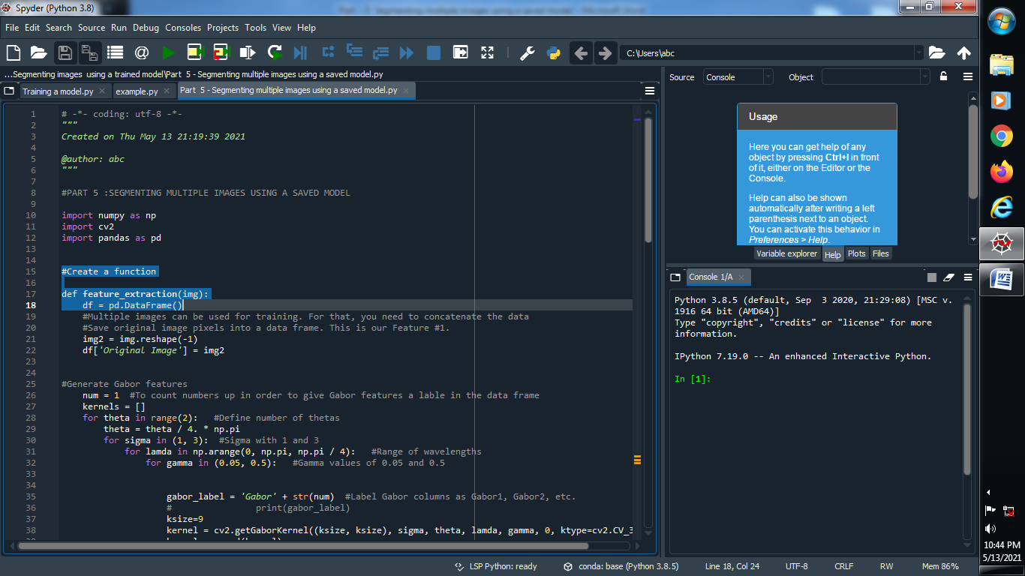

**(2) Put all the things in this function which we are done above parts :**

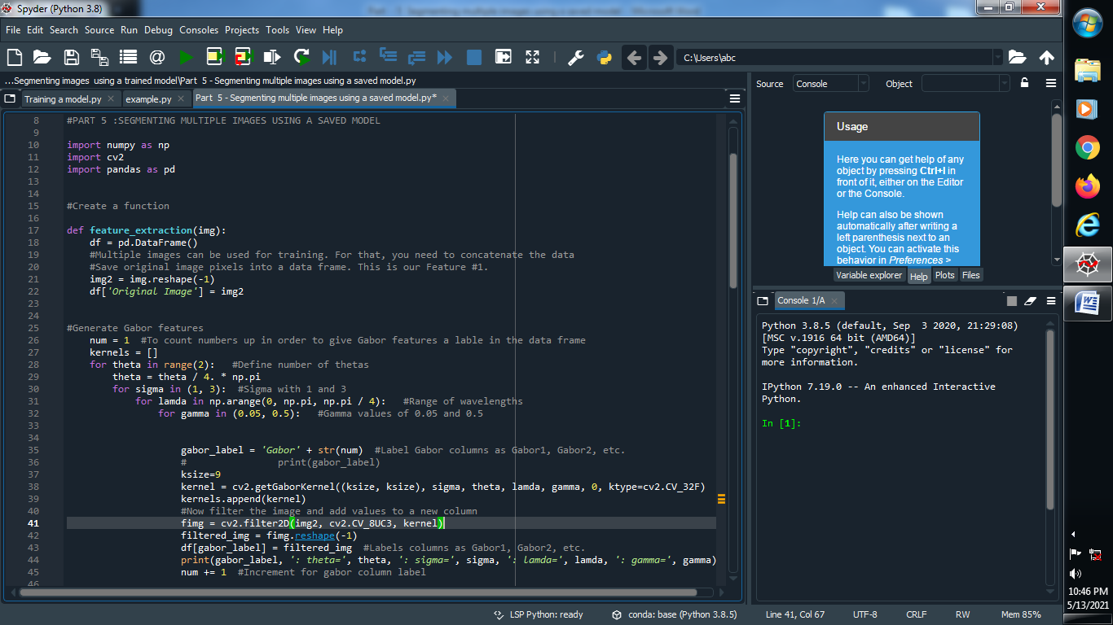

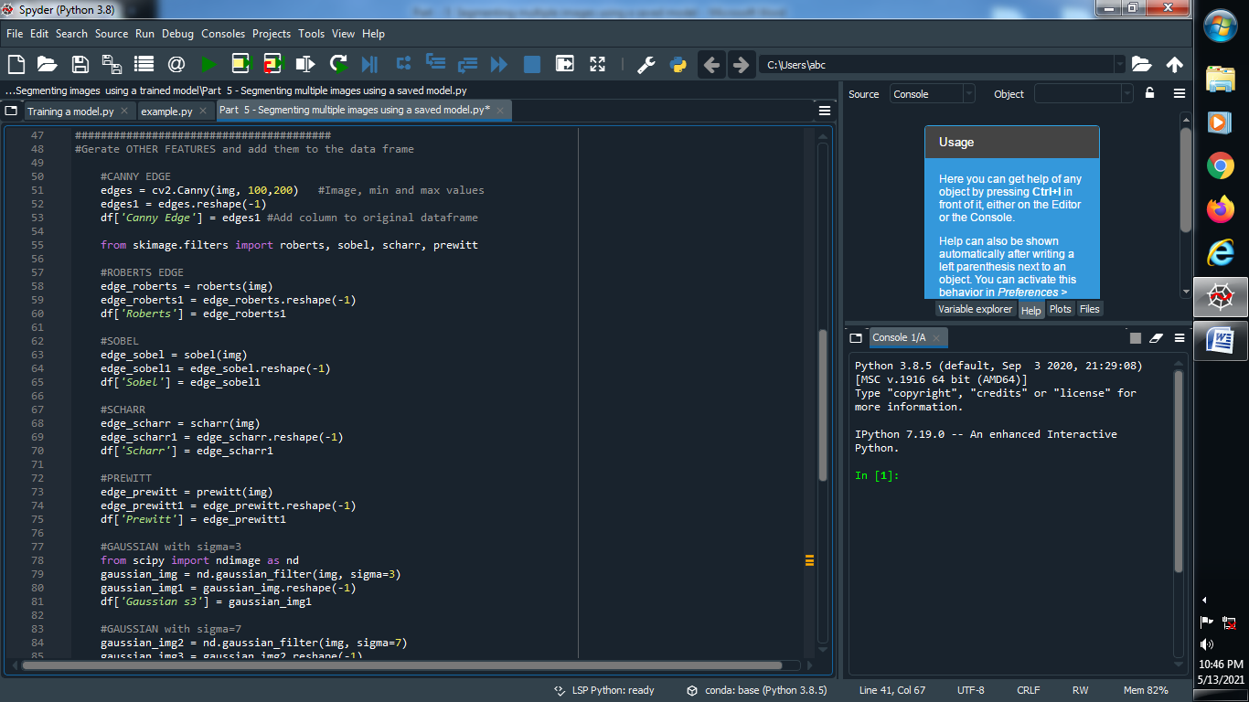

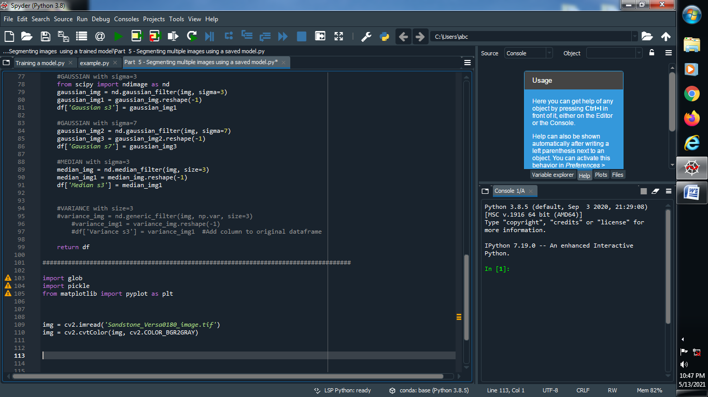

**(3) import glob and pickle library and give one filename :**

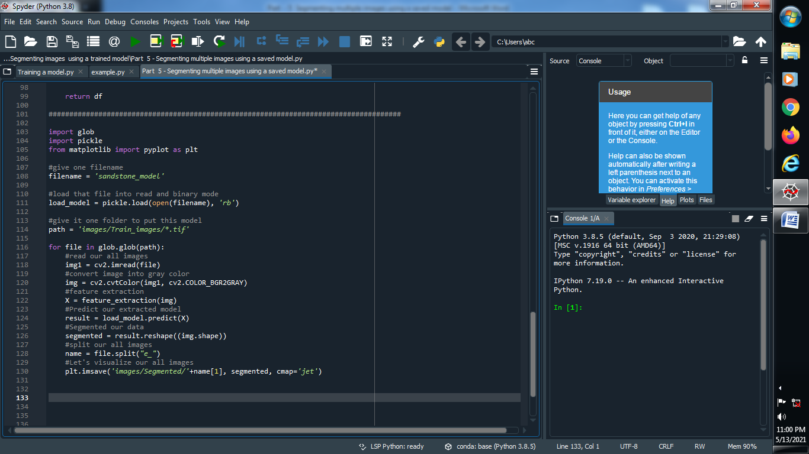

**(4) Load that file into read and binary code :**

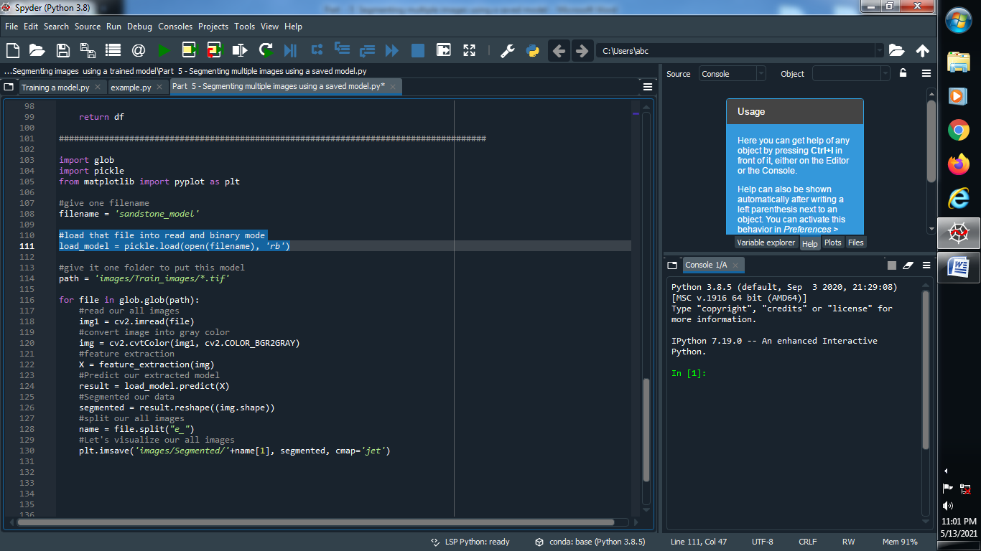

**(5) Give one folder path that we put all this images :**

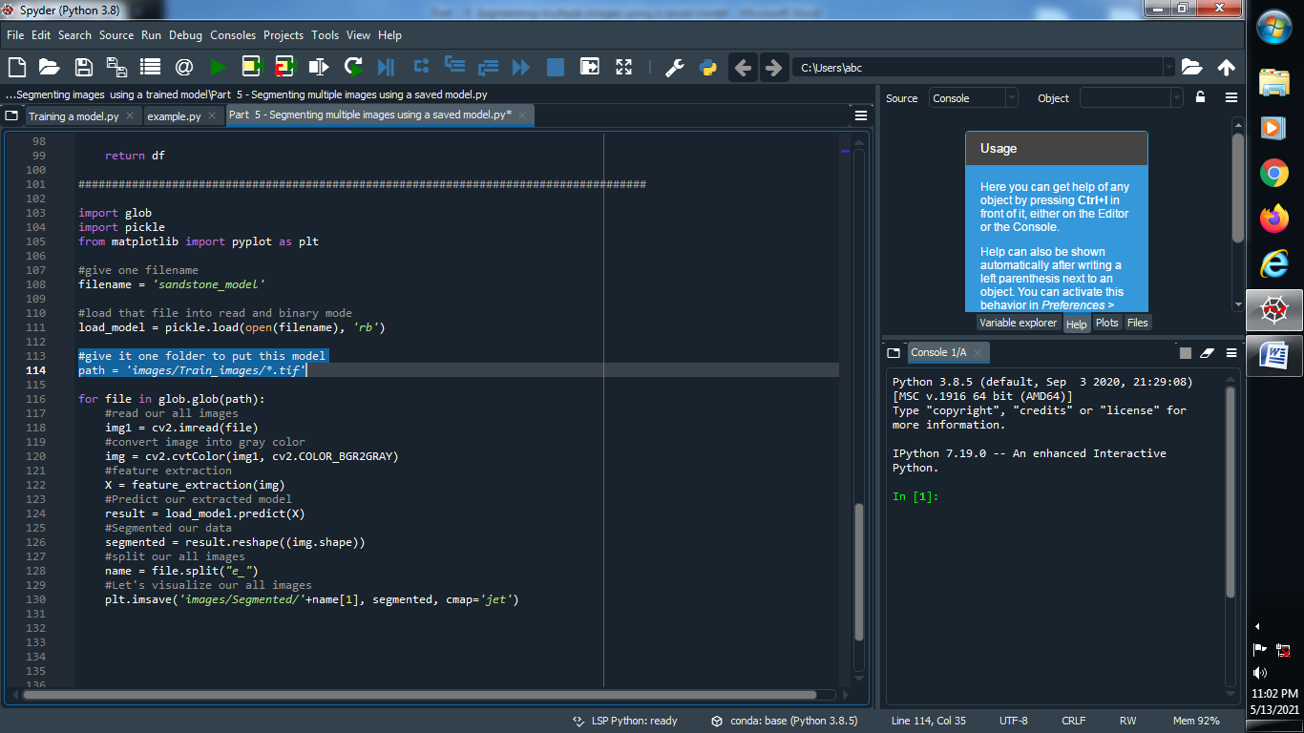

**(6) Create one glob function :**

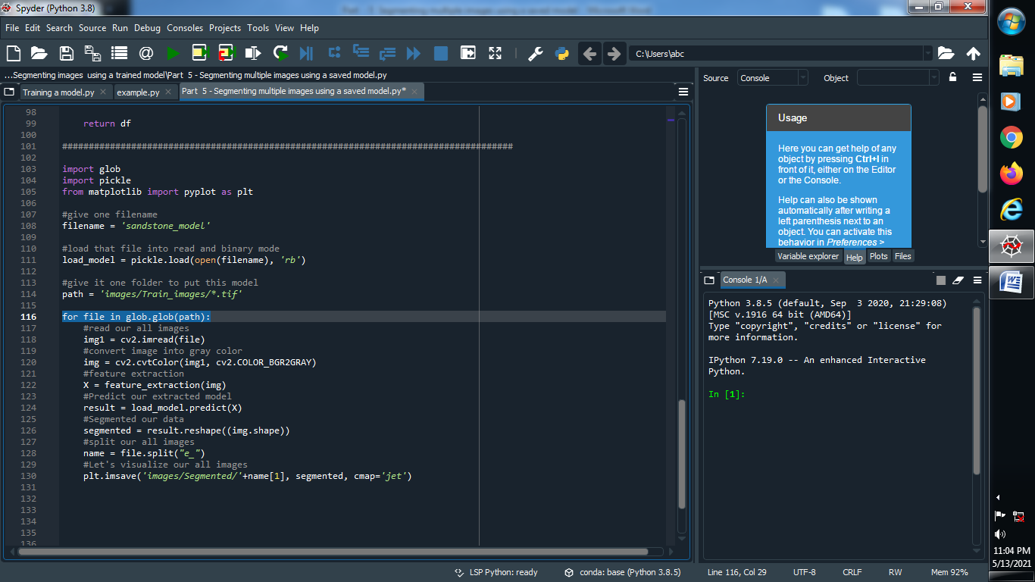

**(7) read all this images and convert it into gray image :**

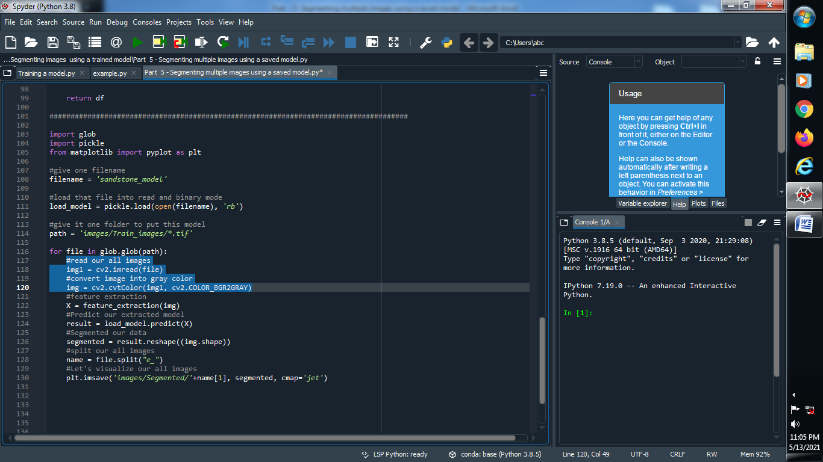

**(8) Extract our features and load our predicted model :**

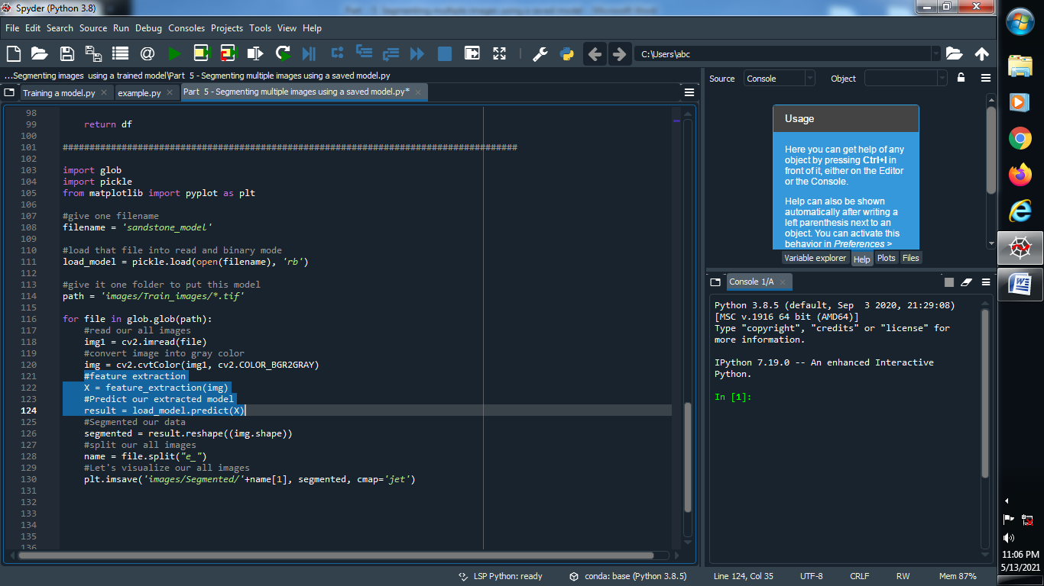

**(9) Segment our data model :**

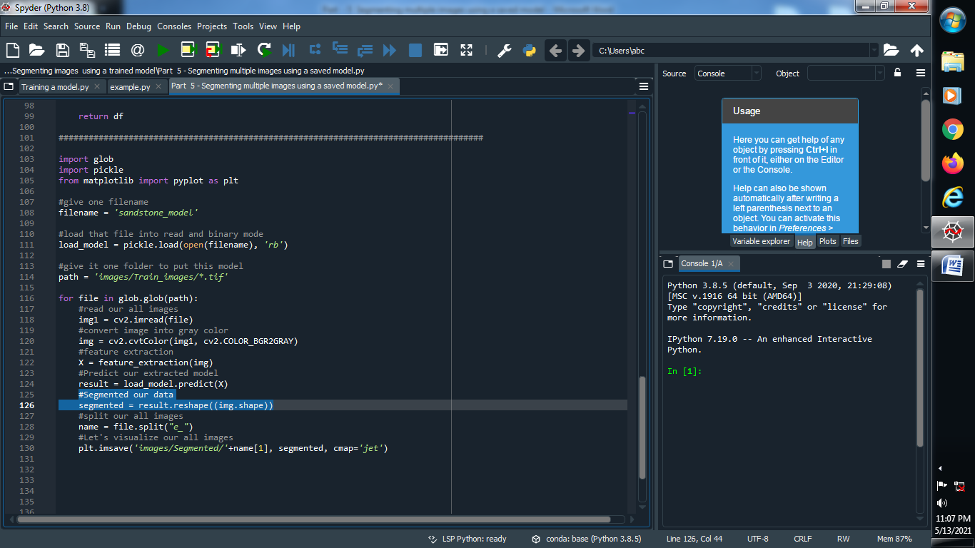

**(10) Give some unique file name for Split our images and than visualize all images :**

